

|  |  |
| --- | --- |
| **Final Project Report** | |
| **Submitted To** | Sir Ali Fatimi |
| **Submitted By** | **Group Leader:**  Maryam Siddiqui (20k-0434)  **Members:**  Eisha Fatima (20K-383)  Mehma Waseem(20K-261) |
| **Date of Submission** | 19th May , 2021 |

**Table of Contents**

1. Problem description………………………………………………………..1
2. Project layout………………………………………………………………1
3. Topics………………………………………………………………………2
4. Main idea…………………………………………………………………...2
5. Project output……………………………………………………………….3

i.Manager …………………………………………………………………..3

ii.Customer service………………………………………………………….4

**Restaurant Management System**

**Problem description**

In our proposed system, we aim to design an effective restaurant system. The program will ask customer to view the menu card and place the order, and we will address the issue of reserving seats for customers, along with choice of takeaway and dine-in. Also, manager will have the authority of guiding regarding the menu card details and ordering system.

**Project layout**

In our proposed system, we had initially aimed to design an effective restaurant system, which we have fulfilled using a restaurant management system. There are two users in the restaurant, i.e. Manager and Customer.

We have limited the access of a manager user by only using a passcode. Once the manager gets access to his account, he is provided with various options. Firstly, the customer service option enables the manager to take Customer’s order along asking for take in or dine in options. This option concludes at generation of bill with implementation of discount (if deal is taken) and 5% gst. We had initially proposed the problem of reserving seats, which we have addressed through the function of Reservation details. It provides the manager with an option to reserve a table, view the reservation chart and cancel reservations for customers.

For billing in the restaurant, the option of bill query lets the manager view the billing record that includes customer name, billing amount and time of order. Also, if there is a clash of the same customer name, the customer can approach the manager regarding this query as search in record helps manager to have a list of same name customer with the stored billing data. Furthermore,options give access to the manager to view the current deals and menu of the restaurant.Lastly, the manager can view the feedback given by the customers using viewing feedback options. This addresses the issue of the manager having authority in the restaurant as he is the one responsible for handling all customer data.

The program enables the customer to mainly choose from three options: viewing their order, giving feedback or exiting. The aim of customers being able to view the menu is addressed in the viewOrder() function, as the customer’s current order is displayed by opening the respective file. While in the feedback() function, the customer enters their feedback for the restaurant, as the answers to the questions are input through strings and then stored in the feedback file. If the customer wishes to quit, they can press exit which closes the customer block in the program.

* **Topics**

-Data abstraction

-Encapsulation

-Data hiding

-Constructor

-Member initialization

-Constant and static data members

-Inheritance

-Polymorphism

-Filing

* **Main idea**

-Manager and Customer login system

-Display Menu card

-Discounted Deals offered

-Reservation

-Reserve a table

-View reservation chart

-Cancel reservation

-Dine-in and takeaway option

-Calculation of bill and generating invoice

-Restaurant feedback (number of stars)

-Given by customer

-Viewed by Manager

* **Project Output**
* **Manager :**

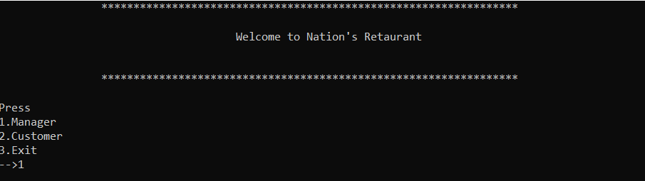

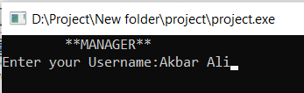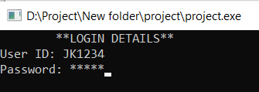

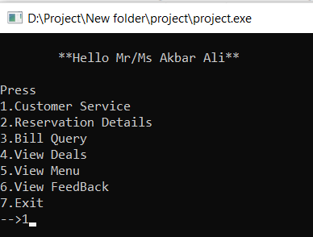

1. **Customer Service**



